DYPIEMR(E&TC)

# Dr. D. Y. Patil Pratishthan’s

**DR. D. Y. PATIL INSTITUTE OF ENGINEERING, MANAGEMENT & RESEARCH**

# Approved by A.I.C.T.E, New Delhi , Maharashtra State Government, Affiliated to Savitribai Phule Pune University

Sector No. 29, PCNTDA , Nigidi Pradhikaran, Akurdi, Pune 411044. Phone: 020–27654470, Fax: 020-27656566

Website : [www.dypiemr.ac.in](http://www.dypiemr.ac.in/) Email : [principal@dypiemr.ac.in](mailto:principal@dypiemr.ac.in)

# Experiment No: 3

**Title:** Reflex Klystron as a Microwave source in laboratory and plot its mode characteristics

# Objectives:

1. To study operation of reflex klystron.
2. To plot the mode characteristics of klystron
3. To observe frequency variation with Repeller voltage.

**Apparatus:**

1. Klystron Power Supply and Klystron with mount
2. Isolator
3. Frequency meter
4. Variable Attenuator
5. Slotted section with Probe carriage
6. CRO
7. Movable Short. etc.

# Circuit diagram:

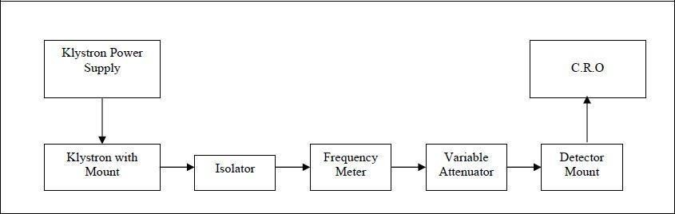

**Theory:**

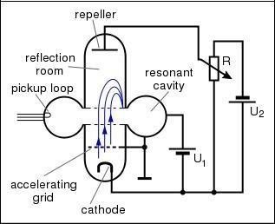

The reflex klystron makes use of velocity modulation to transform a continuous electron

beam into microwave power. Electrons emitted from the cathode are accelerated and passed through the positive resonator towards negative reflector, which reflects the electrons and the electrons turn back through the resonator. Suppose the RF- field exists between the resonators, the electron accelerated or retarded, as the voltage at an increased velocity and the retarded electrons leave at the reduced velocity. As a result, returning electrons group together in bunches. As the electron bunches pass through the resonator, they interact with the voltage at resonator grids. If the bunches pass the grid at such a time that the electrons are slowed down by the voltage then energy will be delivered to the resonator, and the klystron will oscillate.

The frequency is primarily determined by the dimensions of resonant cavity. Hence by changing the volume of the resonator, mechanical tuning of the klystron is possible. A small frequency change can be obtained by adjusting Repeller voltage. This is called electronic tuning. Following figure shows the internal structure of reflex klystron.

# Procedure:

1. Connect the components and equipment as shown in the block diagram.
2. Set the variable attenuator at the minimum attenuation position.
3. Set the mod. Switch of klystron power supply at AM position, beam voltage control knob to fully anti-clock wise and Repeller voltage control knob to fully clock wise.
4. Rotate the knob of the frequency meter at one side fully.
5. Connect CRO with detector.
6. Switch on the klystron power supply and cooling fan.
7. Put on the beam voltage switch and rotate the beam voltage knob slowly up to 270V(max) and observe the beam current which do not increase more than 20 mA. Do not change the beam voltage while taking the readings.
8. Change the Repeller voltage slowly and observe stable square wave with highest peak to peak amplitude.
9. Tune the plunger of klystron mount for maximum output.
10. Rotate the frequency meter slowly and stop at that position, where there is lowest output on CRO. Read frequency meter between two horizontal red lines and vertical marker.
11. Change the Repeller voltage and read the voltage and frequency for each Repeller voltage to get different modes of the klystron.
12. Note the readings in tabular column for every Repeller voltage and draw the graph for klystron modes.

# Basic precautions:

1. Do not look into open end of waveguide while power is on it may damage retina.

2. The Repeller negative voltage should be always applied before beam voltage.

3. The Repeller voltage should be varied in one direction to avoid hysteresis in klystron.

4. Once Beam voltage is applied first, cooling should be provided simultaneously. 5. Frequency meter should be detuned after each frequency measurement.

6. To avoid loading of the klystron an isolator/attenuation should invariably be used.

# Observation Table:

**Beam voltage (Vo) = V**

**Beam current (I) = mA.**

|  |  |  |  |
| --- | --- | --- | --- |
| **Sr. No.** | **Repeller Voltage(VR)** | **Output Voltage on CRO (Volts)** | **Frequency(GHz)** |
| **Mode-1** |  |  |  |
|  |  |  |
|  |  |  |
| **Mode-2** |  |  |  |
|  |  |  |
|  |  |  |
| **Mode-3** |  |  |  |
|  |  |  |
|  |  |  |
| **Mode-4** |  |  |  |
|  |  |  |
|  |  |  |

# Sample Graph

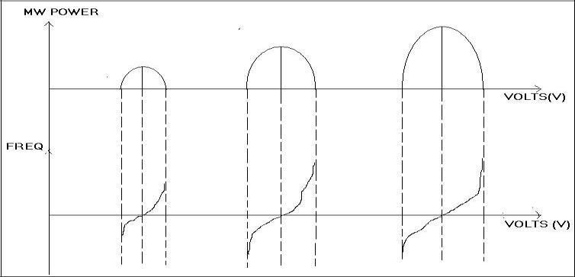

**Result:**

# Conclusion:

**Questions:**

1. What is velocity modulation?
2. What is bunching?
3. List the application of reflex klystron.
4. Importance of multicavity klystron?
5. Write a note on mode of oscillations.

# References:

1.M. Kulkarni, “Microwave and Radar engineering”, 3rd edition, Umesh Publications

2.M L Sisodia& G S Raghuvanshi, “Basic Microwave Techniques and Laboratory Manual”, New Age International (P) Limited, Publishers.